**Homework #1b**

**MSiA Program, Fall 2023**

**Optimization**

**Due: At the start of class on 9/27/23 (Wed)**

------------------------------------------------------------------

***Note on Linear Programming problems***

A good way to learn linear programming is to do it. If you’ve done it before, you can still get insight from these models. For each of the problem, build the model in Excel or Python (I prefer Jupyter Notebooks), or both if it helps you learn. In Excel, solve with OpenSolver (or use Excel’s Solver if you have to—I think it is a little buggy and not as robust as OpenSolver). In either case, I want you to learn Linear Programming. So, make sure you understand the model, make sure you can explain the answer, and convince yourself that you have the right answer.

You will turn in your assignment as a group. But, I strongly recommend that you actually build each of these models yourself. I also suggest that you try to build the models with limited online searches—try to think about how you would model. Making mistakes and taking wrong turns is valuable. This will serve you well and help you learn the material.

We will discuss each model in class and use it as a learning experience.

We will assign each group one of the problems to talk about. You should treat this like a short presentation—but not like a full presentation (no one likes those). We mostly want you to put you on the spot and ask different questions so we can all learn more about optimization. Everyone will have done the problem- so you can present it showing what you did, the answer you got, any debates you had, any mistakes you made-things you tried, what you didn’t like about the model, what you liked, etc.

You are going to talk, and we’ll ask you tough (but fun) questions. And, we’ll all learn something about the models and how to think about them.

1. Transportation Problem.

For this problem, assume there are two coal mines that feed four power plants. Mine #1 has 230 tons available, Mine #2 has 150 tons. The plants need the following tons:

* Plant #1: 80
* Plant #2: 100
* Plant #3: 70
* Plant #4: 130

The cost per unit to go from each mine to each plant is:



For this problem, formulate this as a linear program and find the minimum cost solution.

1. Assignment Problem.

This is a simplified version of the shelf space model. In this model you need to determine which product will go onto which slot on the shelf. For each product, at each location, you know the expected daily profit as seen in this table (which is also in the Excel file):

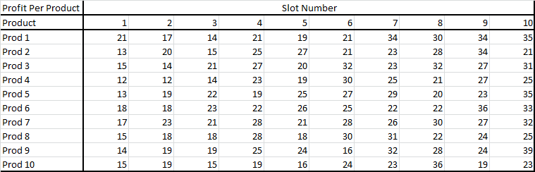

You need to determine what product should be slotted in which location. Only one product can go in each location and each product can only be slotted once.

Once you have your model built, determine what the absolute worse slotting would be. What is the business value for calculating this?

Also, determine the profit if each item was slotted in its best possible location- not considering the overall feasibility of the solution. What does this number tell you from a business point of view?

1. Simplified Berlin Airlift Model.

Do the problem in the Berlin Airlift PDF You don’t have to answer the questions at the bottom. I just want you to build and explain the model you built.

Note, that you need to make a few modifications. (For some reason, this problem did not do a good job of keeping track of time periods).

You need to modify:

* Assume that each plane can make 21 trips per week
* Assume that the total weekly budget is $7,000,000

Instead of the directions they give for solving the problem, do this:

* Set up the model in Excel (you should at least try this in Excel and if you like try it in Python too) and solve with OpenSolver (We definitely want you to try it in OpenSolver)
* What if the budget was $5,000,000, what is the solution? What is wrong with the solution? What are at least two ways to resolve this problem?

1. You are working for a distributor of vegetables. You can see the data on the vegetables in the spreadsheet. You have the price that you purchase, the price you sell, and the minimum quantity you have to sell (by contract), the max you can sell (the most the market will bear), and the cubic feet per carton. In your business you receive cases of vegetables from your suppliers at the start of the week. Your warehouse only has room for 18,000 cubic feet of product. And, your supplier only allows you to purchase up to $30,000 of product per week.
   1. Set this up and solve as a linear program
   2. What insights do you get from the solution.